DRAGON BOAT Z

USER

MANUAL

ENG1

____________________

Assessment 2

____________________

Release Date: 10/02/2021



Table of Contents

DBZ User Manual 2

HOW TO USE THIS MANUAL 2

HOW TO PLAY 3

FIGURES 9

# DBZ User Manual

## HOW TO USE THIS MANUAL

Fun fact:

The York Rotary Dragon Boat Challenge has been held annually since 2003.  
 

Ever wanted to race Dragon boats down the River Ouse? Of course, the answer is yes and we have just the game for you. DragonBoat Z!



Dragon Boat Z is a single-player Boat Racing game based on the annual Dragon Boat Race held in York along the River Ouse. In Dragon Boat Z, the player competes against 6 AI opponents, racing their dragon boats across 3 legs to achieve the fastest time to cross the finish line.

In this manual, you will learn how to play this game. The manual is divided into two sections. The first sections covers the basics of playing the game as well as the features that the player can use. The second section presents various figures to show the player how different items are represented inside the game. This is made to allow for quick referencing while you’re playing the game.

## HOW TO PLAY

Once the game is launched, starting a game is as easy as clicking on New Game or if you have a previous save click on Load Game where you will be able to see the 3 game save slots. Don’t forget to use the ESC button to get back from any menu.

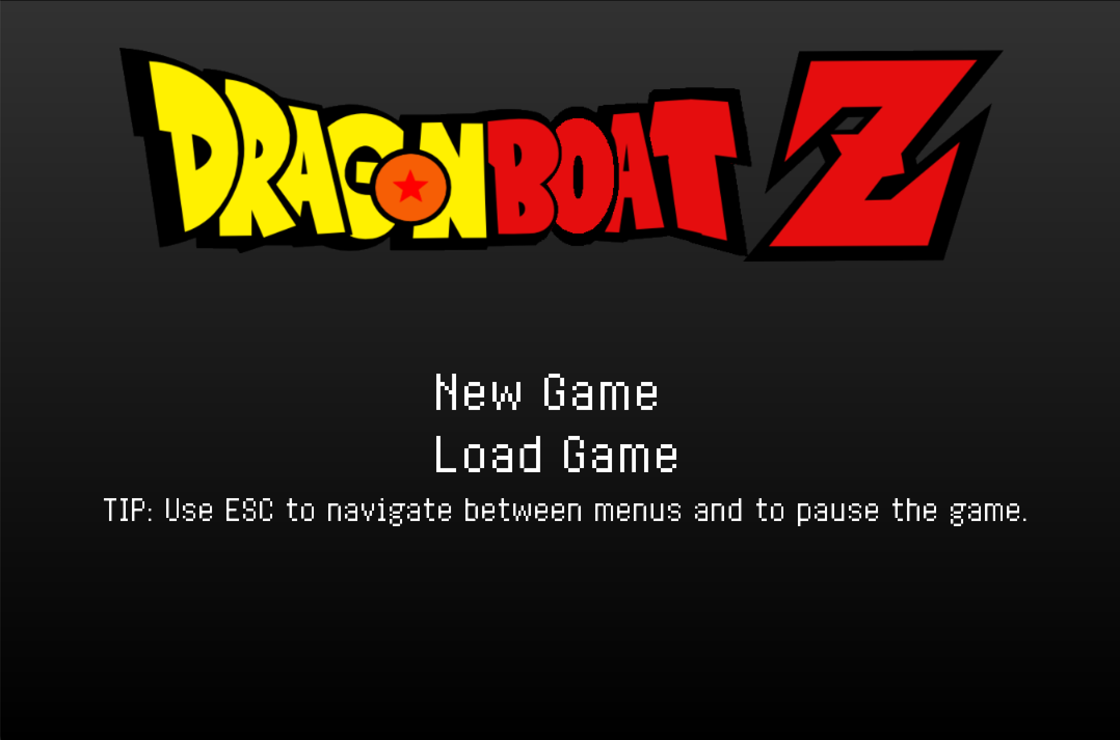

If you chose to start a new game, you will get to pick the difficulty you want. Difficulty will impact the number of obstacles and your opponent’s speed. Afterwards, click on any boat in order to advance and start the race. The start screen includes information about the specs of the different types of boats and also includes game controls. The specs are explained in Figure 2 on page 8

The aim of the game is to move in the direction of the red arrow (shown below) and reach the finish line before the enemy boats around you. Whilst doing so, you should avoid obstacles as colliding with obstacles results in decreasing the boat’s robustness. Receiving too much damage will lead to the boat sinking and the game would be over. Boats can also store the powerups that are spawned on the river. Obstacles and Powerups are explained in more detail on pages 6-7 and in the Figures section.

Please note that regardless of the boat chosen, your boat will always be at the center of the screen in the middle lane.

Once all the boats are lined up at the start line as above, a ‘W’ key input is required in order to start the race for every boat. This will also allow the user boat to accelerate and the timer will start counting at the top right-hand corner of the screen. Leaving the original lane of the boat leads to time penalties and this is also indicated at the top right-hand corner of the screen (see Labels).

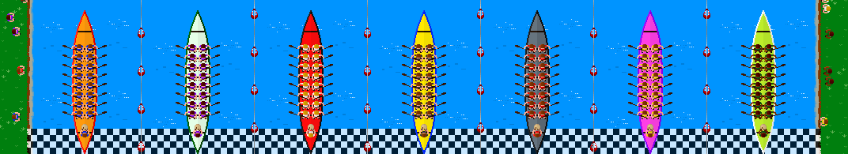

As the game progresses, Obstacles will begin to spawn on the river. These include logs, geese and rocks. Only geese can move across the river.

Along with Obstacles, Powerups also randomly appear on the river as a mystery box (see Labels). The Golden Feather allows the boat to hit obstacles without receiving damage for a limited time. The Hammer repairs the boat by removing any damage received. The Speed Arrows give the boat increased speed for a limited time. The Move Boost increases a boat’s maneuverability for a limited time. Lastly, the Watch decreases the overall lap time of the boat.

After each leg, you can see your position on the leader board. You can advance to the next race by clicking anywhere onscreen. After the third leg, if you manage to make it into the top 3, you can then advance to the final.

If you want to pause the game at any point, Using the ESC key will get you to the pause screen where you can save the current game or exit the game. Please note that the game has 3 save slots, which will be overwritten in the order they were first made if you try to save after they are filled up.

## FIGURES

Figure 1 (Boat Controls):

|  |
| --- |
|  |
|  |
|  |
|  |

Figure 2 (Boat Specs):

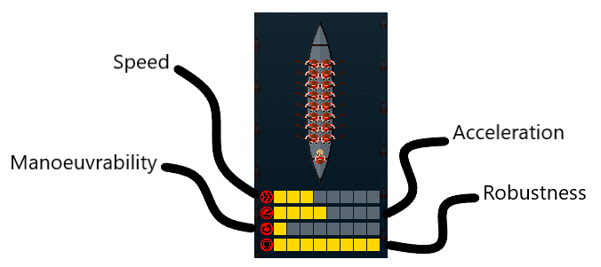

Figure 3 (Start Line):

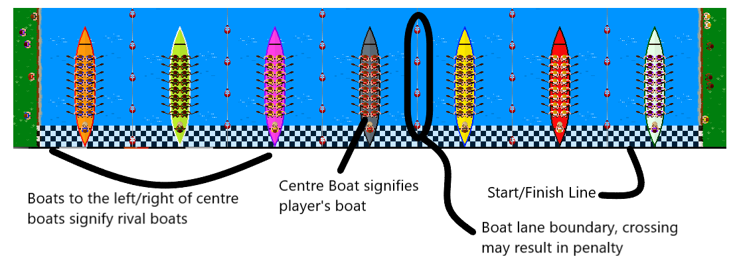

Figure 4 (Progress Bar):

Figures 5,6 (Obstacles):

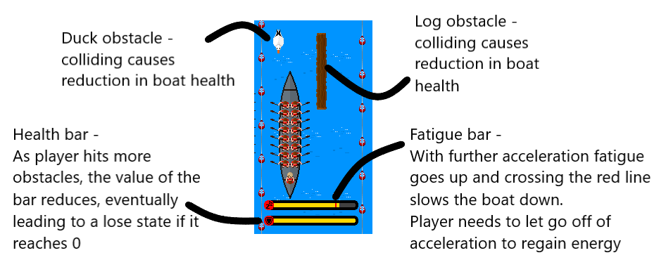

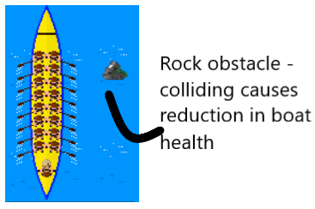

Figures 7,8 (PowerUps):

